# AW9e Confidence interval estimate for slope β1

An alternative to using the F-test or t-test to test whether a significant relationship exists, is to find a confidence interval and see if the H0: β1 = 0 is included within the confidence interval. The confidence interval for the slope is given by re-arranging equation (1) to make β1 the subject of the equation as given by equation (2).

$t= \frac{b_{1}- β_{1}}{s_{b_{1}}}$ (1)

$β_{1}=b_{1}±t×s_{b_{1}}$ (2)

This equation implies two border values for β1 with the confidence interval lying between these two values.

**Example**

Re-consider textbook Example 8.1 and calculate a 95% confidence interval for the slope coefficient of the predictor variable. Figure 1 illustrates the Excel solution.

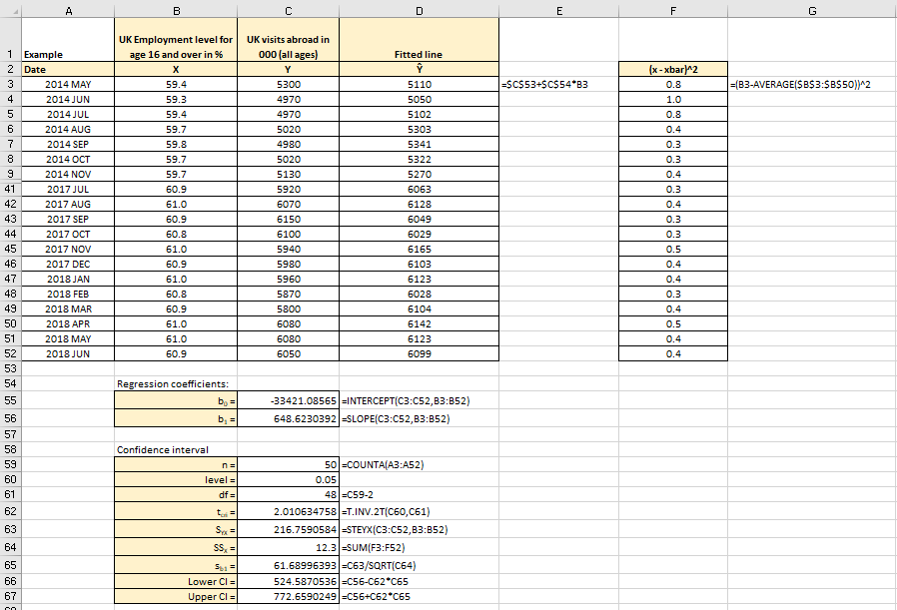

Figure 1

**Excel solution**

x: Cells B3:B50 Values

y: Cells C3:C50 Values

b0 = Cell C53 Formula:=INTERCEPT(C3:C52,B3:B52)

b1 = Cell C54 Formula:=SLOPE (C3:C52,B3:B52)

ŷ= CellsD3 Formula:=$C$53+$C$54*B3

Copy formula down D4:D52

(x – xbar)^2= Cell F3 Formula:=(B3-AVERAGE($B$3:$B$52))^2

Copy formula down F4:F52

n = Cell C57 Formula:= COUNTA (A3:A52)

level = Cell C58 Value

df = Cell C59 Formula:=C57-2

tcri = Cell C60 Formula: =T.INV.2T(C58, C59)

SYX = Cell C61 Formula:=STEYX(C3:C52,B3:B52)

SSX = Cell C62 Formula:=SUM(F3:F52)

sb1 = Cell C63 Formula:=C61/SQRT(C62)

Lower CI = Cell C64 Formula:=C54-C60*C63

Upper CI = Cell C65 Formula:=C54+C60*C63

From Excel, the 95 % confidence interval is between 524.58 and 772.65. We can say that the confidence interval states that for a one percent increase in the employment level in the UK, the number of UK visits abroad is estimated to increase by 648.62, with 95% certainty that it will be at least 524.58 but no more than 772.65 per the percentage point.